D424 – Software Engineering
Task 4
Capstone Proposal Project Name: |   Legends of the Lance
Student Name: | Joseph “Joey” Guynes

Deployment 3
Justification 3
Container Implementation 3
GitLab Documentation 4
Affirmation 4
Panopto Recording 4
Affirmation 4

Deployment
The final product was deployed to Render web hosting.

Justification
Initial deployment options were Azure or Render. After testing the software on both hosts, the SignalR with Azure had issues dropping repeatedly causing user errors, whereas in Render, the SignalR stayed connected allowing for a more seamless user experience.
Additionally, Render was chosen for its ease for both horizontal and vertical scaling. This will allow the program to take on more users (horizontal scaling) by increasing the number of servers and nodes needed to facilitate the users. As the game grows, we will be able to scale vertically by adding more CPU and RAM to allow the growth of the software to run seamlessly.

Container Implementation
Legends of the Lance utilizes a multi-stage Dockerfile to create my containerization.
- FROM mcr.microsoft.com/dotnet/sdk:10.0 AS build
  - This command creates a clean slate of dotnet (10.0) machine and gives it the name “build” so it can be referenced later.
- WORKDIR /src
  - This command names the WORKDIR as src, so that the build is predictable and organized.
- COPY . .
  - Here the entire project is copied into the src directory.
- RUN dotnet restore
  - Here the NuGet dependencies are restored ensuring that the container has access to all packages in the environment.
- RUN dotnet publish -c Release -o /app/publish
  - Here Legends of the Lance is built in Release mode, so that only the compiled binaries are needed, this creates the ability to not need the Software Development Kit (SDK).
- FROM mcr.microsoft.com/dotnet/aspnet:10.0 AS final
  - This creates the ASP.NET runtime image. This is smaller and allows production optimization. It keeps it lightweight and secure.
- WORKDIR /app
  - This command changes the working directory to app, creating a clean location space for running Legends of the Lance.
- COPY --from=build /app/publish .
  - Here the published output is copied to the app directory. This keeps the final image small.
- EXPOSE 8080
  - Here Legends of the Lance server is exposed on Port 8080, this allows the the frontend to communicate with the server.
- ENTRYPOINT ["dotnet", "LanceMudCapstone.dll"]
  - Here Legends of the Lance sets the container to be self-starting and production ready.

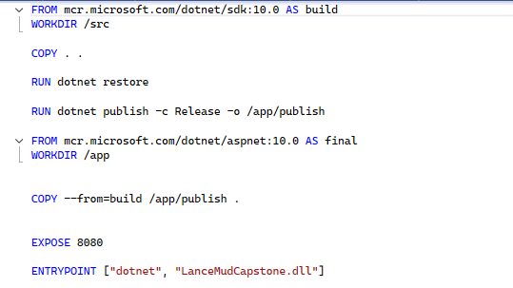

GitLab Documentation

Affirmation
The zip file is attached to the submission.

Panopto Recording

Affirmation
The hyperlink is attached to the submission.

